# **Portfolio Task 2a: Qualitative Data Exercise – Annotated Image Exemplar**

Birds watching

Camera

Binocular

Birds watchers

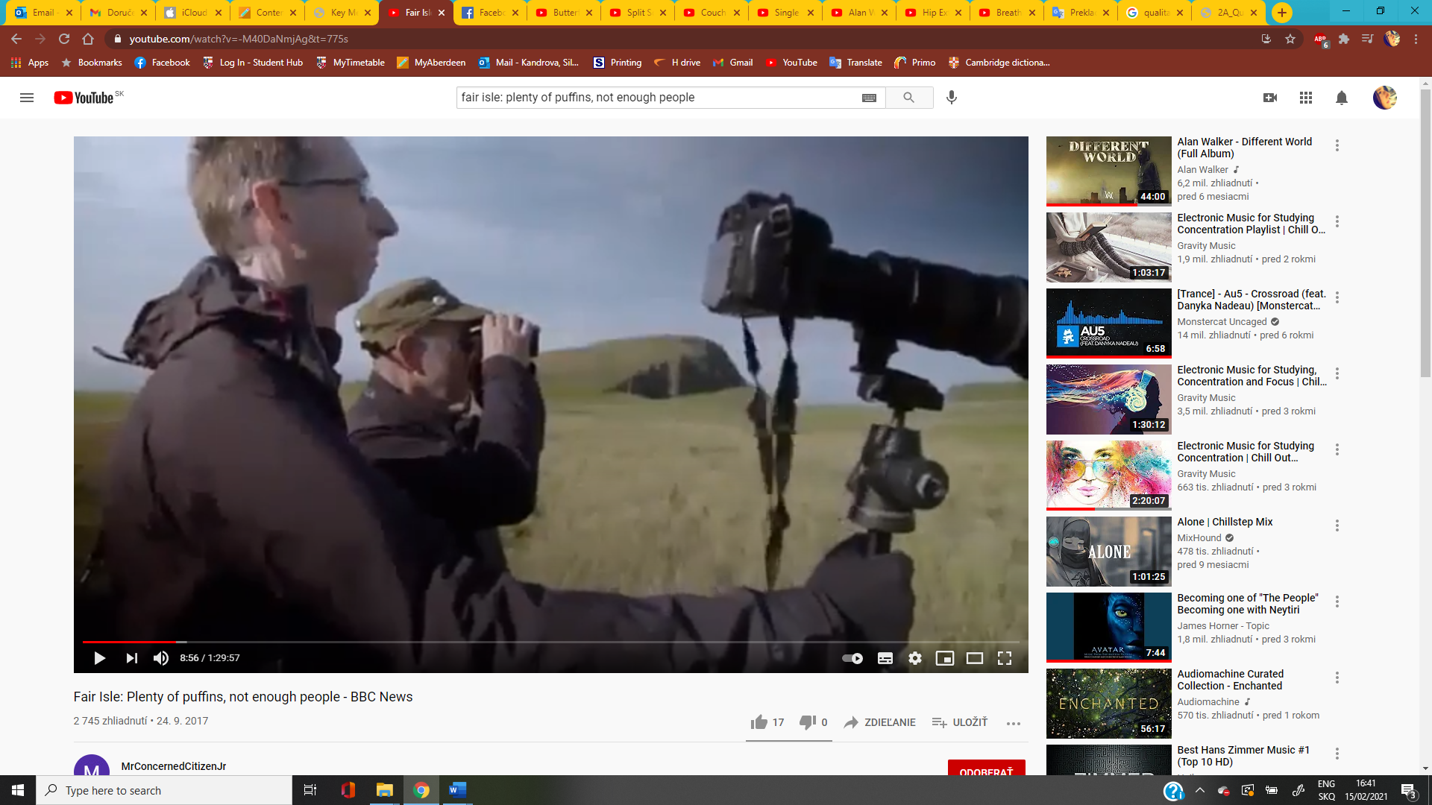

**Image from:** Fair Isle: Plenty of puffins, not enough people - BBC News, 10.9.2017

**Timestamp:** 00:08:56

**Available at:** https://youtu.be/32gas5YYO1g

**Annotated by:** 51985563

**Description:** Two men stands near the cliff and observe birds. One man uses binocular in order to see birds in better resolution. The second man with glasses holds tripod with a camera to take some pictures. Based on their clothes, we can assume that it is autumn or spring, with a nice sunny day.